Broadcast Traffic Control using SDN (Mininet + POX)

Broadcast Traffic Control using SDN

Name:
USN / Roll No:
Course:
Faculty:
College:
📌 Objective
To control excessive broadcast traffic in a network using Software Defined Networking (SDN) by detecting broadcast packets and limiting unnecessary flooding.

🧠 Concept
In traditional networks, broadcast traffic is flooded to all devices, causing congestion.
Using SDN, the controller can intelligently detect broadcast packets and control their flow.

🛠 Tools Used
- Ubuntu (VirtualBox)
- Mininet (Network Emulator)
- POX Controller (SDN Controller)
- Python

⚙️ Implementation Steps
Step 1: Install Mininet
sudo apt update
sudo apt install mininet -y
Step 2: Install POX Controller
git clone https://github.com/noxrepo/pox
cd pox

Step 3: Create Custom Controller
File: broadcast_control.py
from pox.core import core
import pox.openflow.libopenflow_01 as of

log = core.getLogger()

def _handle_PacketIn(event):
packet = event.parsed

# Detect broadcast packets
if packet.dst.is_broadcast:
log.info("Broadcast detected - limiting traffic")
return

# Normal forwarding
msg = of.ofp_packet_out()
msg.data = event.ofp
msg.actions.append(of.ofp_action_output(port=of.OFPP_FLOOD))
event.connection.send(msg)

def launch():
core.openflow.addListenerByName("PacketIn", _handle_PacketIn)

Step 4: Run Controller
cd ~/Desktop/pox/ext
python3 ../pox.py broadcast_control

Step 5: Run Mininet
sudo mn --topo single,4 --controller remote

Step 6: Test Network
pingall

Step 7: Test Broadcast Control
h1 ping -b 10.0.0.255

📊 Results
- Normal communication works successfully (0% packet loss)
- Broadcast packets are detected by controller
- Broadcast traffic is blocked
- Network congestion is reduced
- The system was tested using Mininet. The controller successfully detected broadcast packets and prevented flooding. The behavior was validated using ping and broadcast testing.

📸 Screenshots
Fig 1: Mininet pingall output

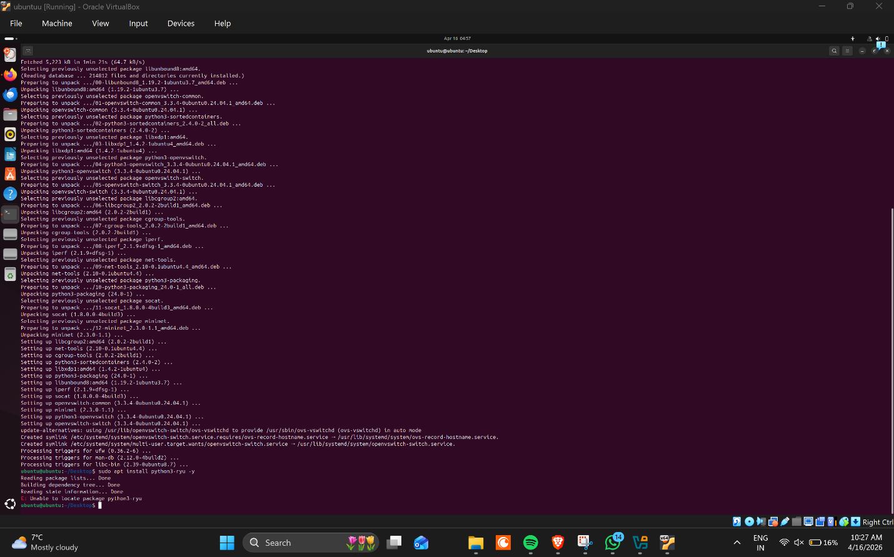
Fig 2: POX controller running

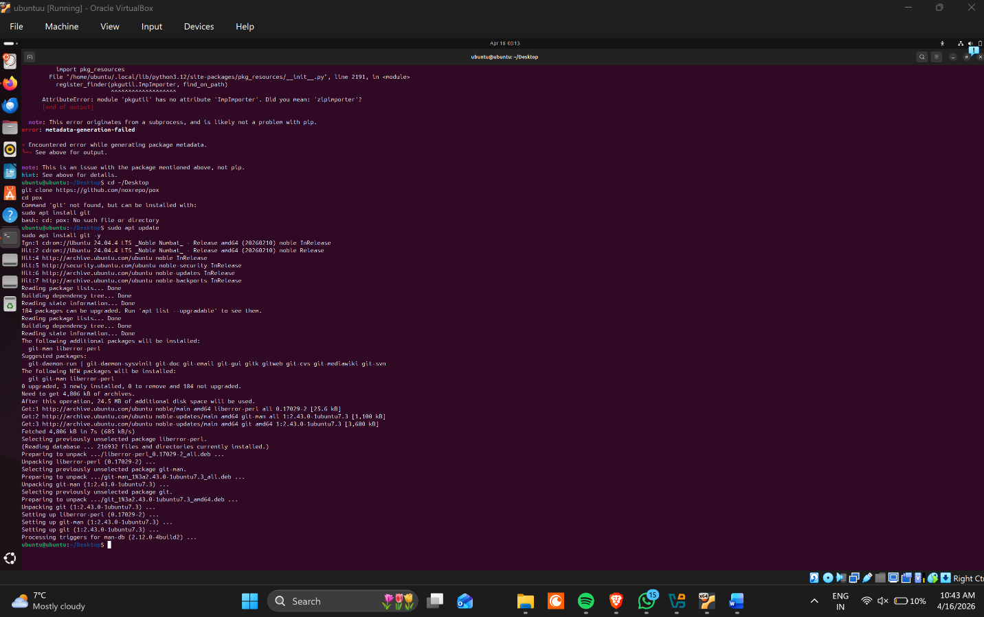
Fig 3: Broadcast ping command
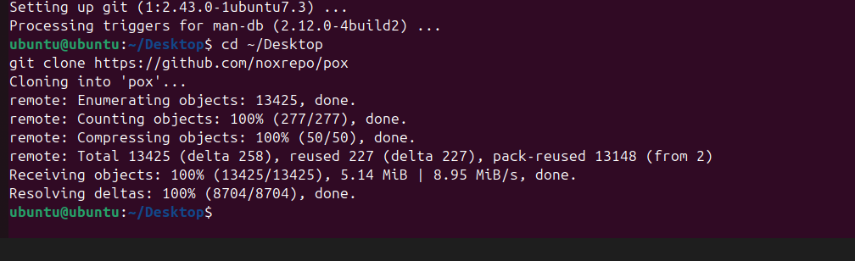

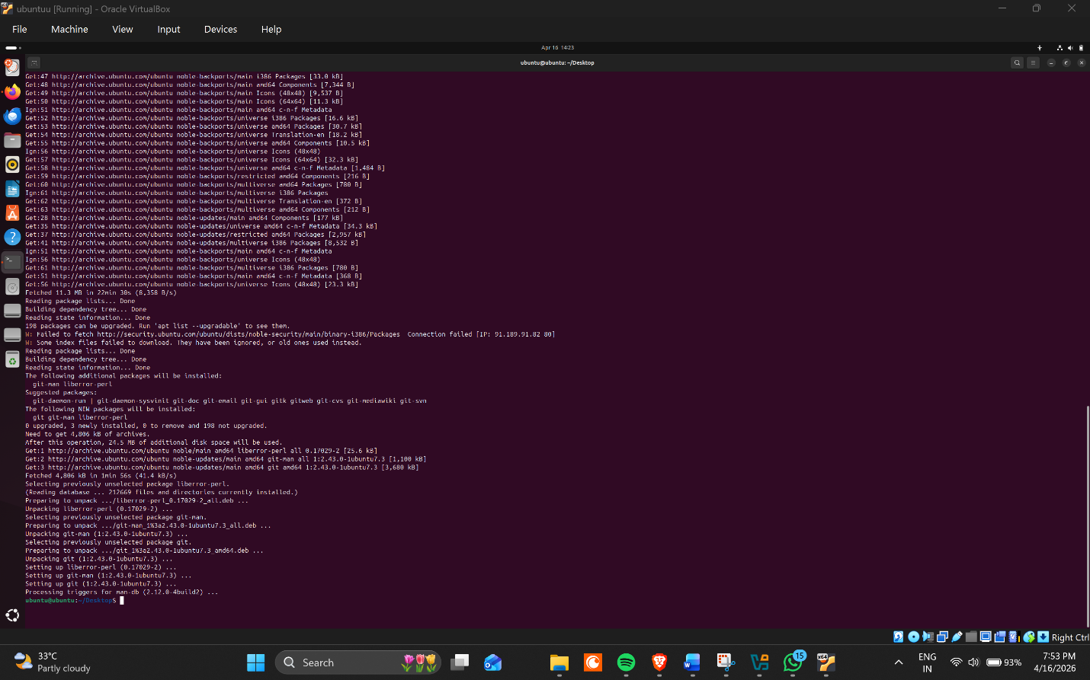
Fig 4: Broadcast blocked result
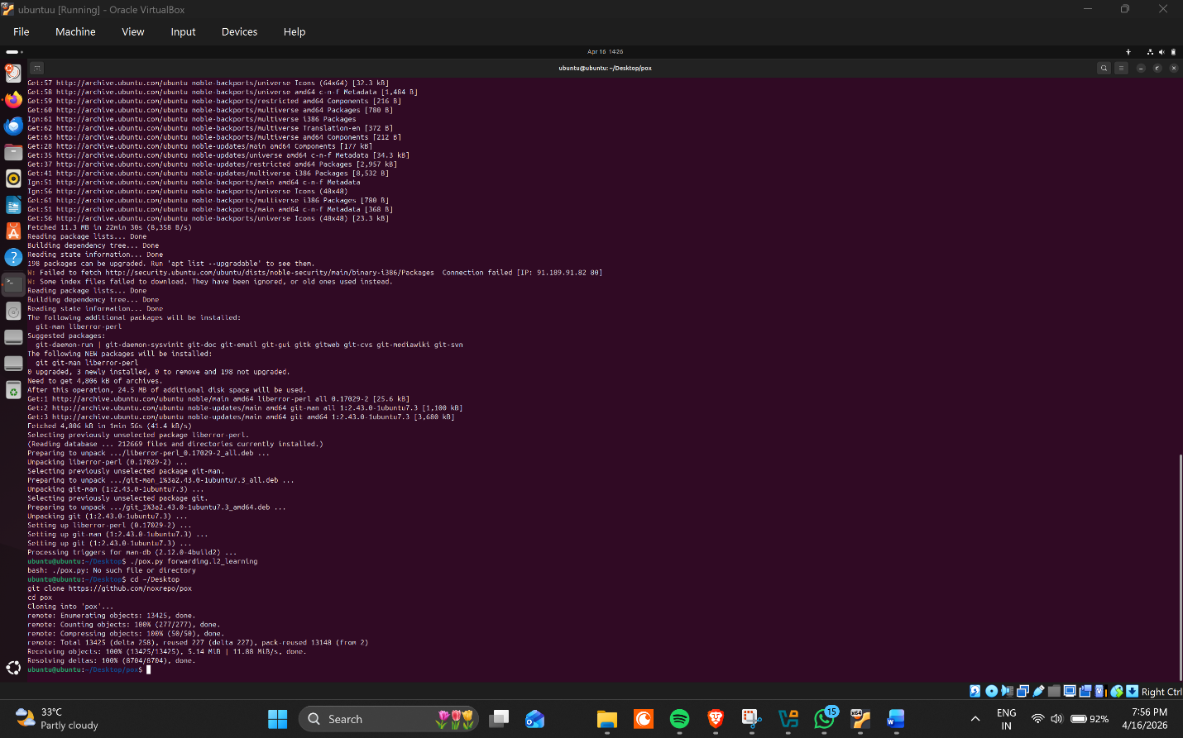

✅ Conclusion
The project successfully demonstrates how SDN can be used to control broadcast traffic. The controller detects and prevents unnecessary broadcast flooding, improving network efficiency.

🚀 Future Scope
- Dynamic rate limiting
- Broadcast storm detection
- AI-based traffic control

This demonstrates the advantage of SDN in providing centralized control over network traffic.

